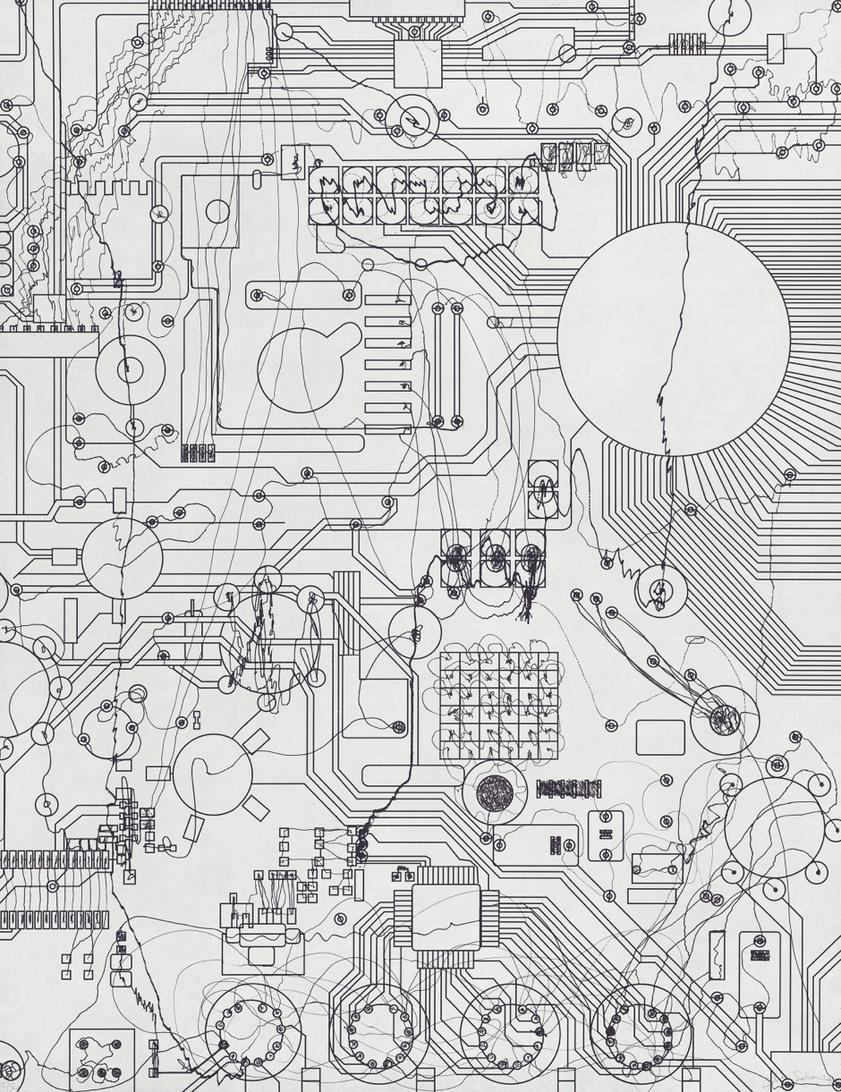
FOR IMMEDIATE RELEASE – February 22, 2022

Heather Gaudio Fine Art
66 Elm Street
New Canaan, CT 06840
(203)801-9590
www.heathergaudiofineart.com
email: rachael@heathergaudiofineart.com

Heather Gaudio Fine Art PROJECTS is delighted to present Analía Sabán: Recent Prints, a solo exhibition featuring recent series of the artist’s graphic works. The show, which runs March 26th- May 21, has been made possible with the generous collaboration of master printmakers Gemini G.E.L. in New York City.

Sabán is known for reconfiguring traditional notions of painting and printmaking, often using the actual material as the subject of the work itself. Her work plays with art historical references and traditions of techniques and technology, creating experimental and witty dialogues between the mediums and processes she is working on.

The artist’s fascination with line work is evident in her Circuit Boards and Transcending Grids, her most recently produced series of prints. These etchings reference different systems of fabrication and artistic mediums. In the Circuit Boards etchings, Sabán integrates computer-designed lines with others created with a handheld Dremel (an electronic rotary tool.) The system of lines inter-twine creating switchboard imagery across the page, their contrasting definition and loose and hard-edged marks bringing an energized synergy to the prints. The Transcending Grids combine printmaking with painting, a series of eight prints where the artist incorporates linen squares on the paper with the use of chine collé. She simultaneously applies inked colored lines (black, white, red, yellow, and blue) to create loosely lined grids, their fringes contrasting with the rigid marks of the deeply etched copper plate they were printed on. These prints are reflections of the artist’s preoccupation with traditional approaches to color, texture, and mark-making.

Other works included in the show delve into Sabán’s conceptual investigations of printmaking as a medium. This One series, created in 2020, comprises of three etchings that illustrate different sized stacks of paper. One pile presents a full edition of 25 sheets, the second shows an edition of 50 and the third image is a stack of 100 prints. Each of the stacks also includes extra impressions that accompany the numbered edition, such as the AP (artist proof) and SP (special proof.) A self-referential arrow rendered in red ink indicates exactly which sheet of paper in the image corresponds to the signed and numbered impression of the print. These prints are a clever and witty reflection about the nature of printmaking and the traditional distribution of the physical edition.

Above: Analía Sabán, Circuit Board #2, 2-color aquatint etching with hardground and drypoint

Generations of a certain age will instantly recognize another print executed in the same year as the This One etchings. The title and composition of Pong is a direct reference to the early Atari computer game released in 1972, the first and arguably the most historically significant video game ever produced. The black and white abstract print echoes the visual economy of the game, the lines and dot of the “ball” that bounces across the screen. The markings are evocative of early Minimalist paintings with their reductive geometric forms presented serially against a neutral background. Unlike Minimalism, however, which rejects a narrative, Pong is a direct visual reference to a video game and a cultural moment in history.

Other prints in the exhibition disrupt standard printmaking practices and at the same time manage to re-invigorate the medium which is long steeped in technical traditions. Pressed Paint sheds light on the essential definitions of painting, sculpture, and printmaking. Sabán crafted a pillowcase-like sack of unprimed linen and filled it with one half-gallon of acrylic paint. The filled bag was then squeezed through the printing press just far enough so that the thick layer of paint spilled out of the open side. Mounted on the wall, this work seems frozen in time, with streaks of color saturating the fabric in a cascading pattern, while the paint peering out of the bottom of the bag reveals the evidence of the process. This printed edition is both a sculpture and a painting that draws attention to the inside of the object, not just the surface. Because of the nature of the process, variations occur, and no two prints from this series are exactly the same.

The same holds true with the Pressed Paint works, a series where stencils in the various shapes of pitchers were filled with ink and the surface was allowed to partially dry. The print was then run through the printing press, forcing the wet under-layers of dark blue color smear out and across the paper in different configurations. The hand of the artist is removed in this final process, allowing for the printing machine to take over, hence the unpredictable result. Some of the imagery resemble clouds or puddles, while others seem like shadows or even contours of landscapes.

Sabán was born in Buenos Aires and currently lives and works in Los Angeles. She received her BFA from Loyola University in New Orleans, followed by an MFA from University of California in Los Angeles. Her works are represented in multiple public and private collections including the Los Angeles County Museum of Art; the Getty Research Institute, Los Angeles; the Houston Museum of Fine Arts; the Albright-Knox Art Gallery, Buffalo; and the Centre Georges Pompidou in Paris.
Heather Gaudio Fine Art PROJECTS, is a new venue designed to display artworks outside the scope of the gallery’s program. Through collaborations with artists, private dealers, and galleries in New York City and beyond, PROJECTS exhibits blue-chip, contemporary masters and site-specific installations. The aim is to diversify the art landscape and conversation, presenting collectors and the community with alternative engaging experiences and acquisition opportunities. For more information and/or high-res images, please contact Rachael Palacios, rachael@heathergaudiofineart.com.

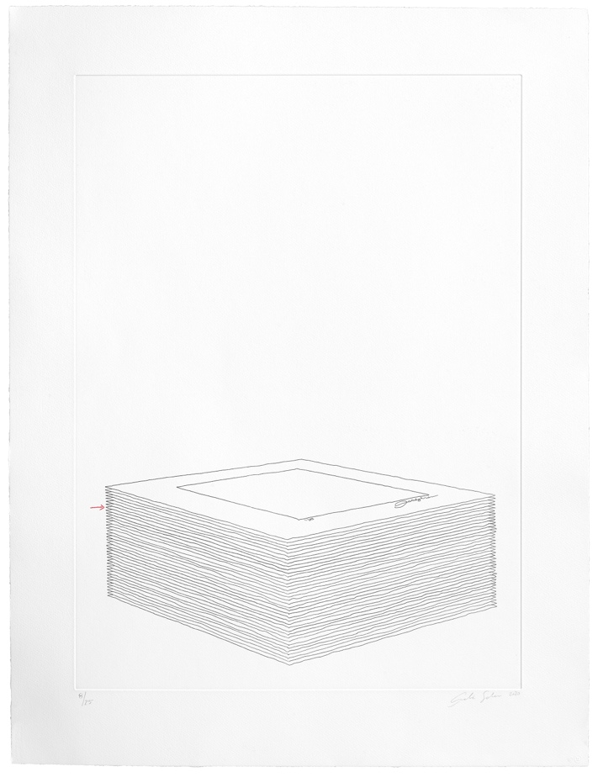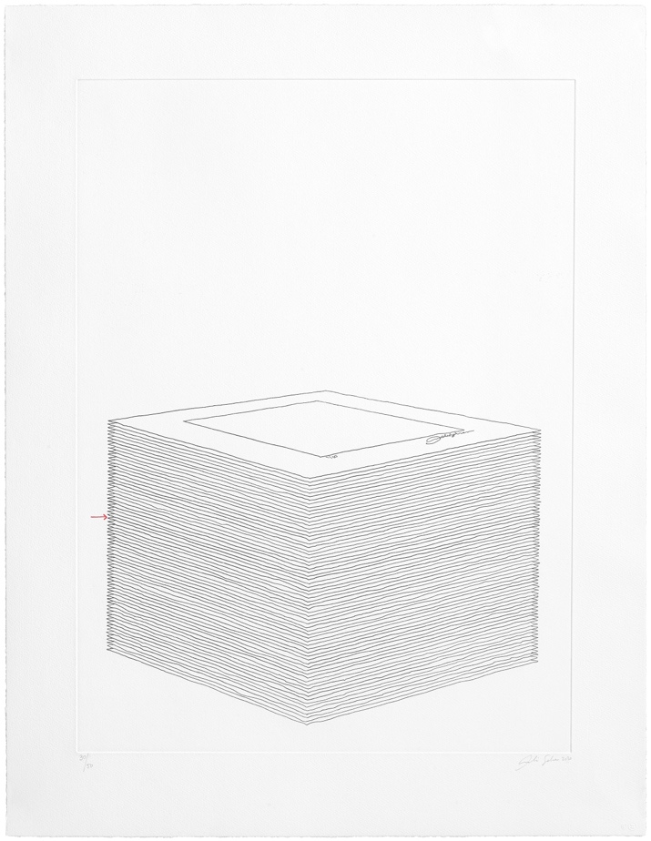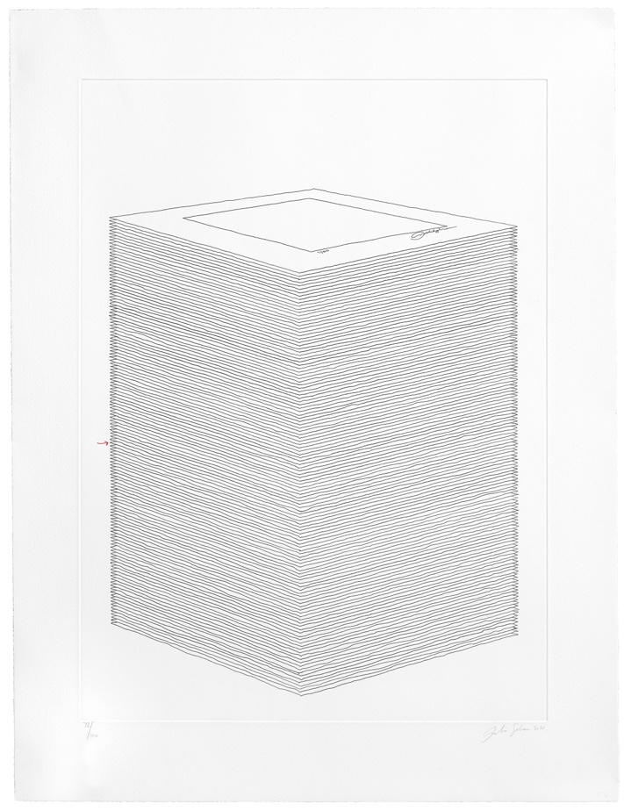

Analía Sabán, This One (Edition of 25, of 50, of 100), 2020, three 1-color etchings with color pencil
36 7/8 x 28 ¼ inches each
Edition of 25, 50 and 100
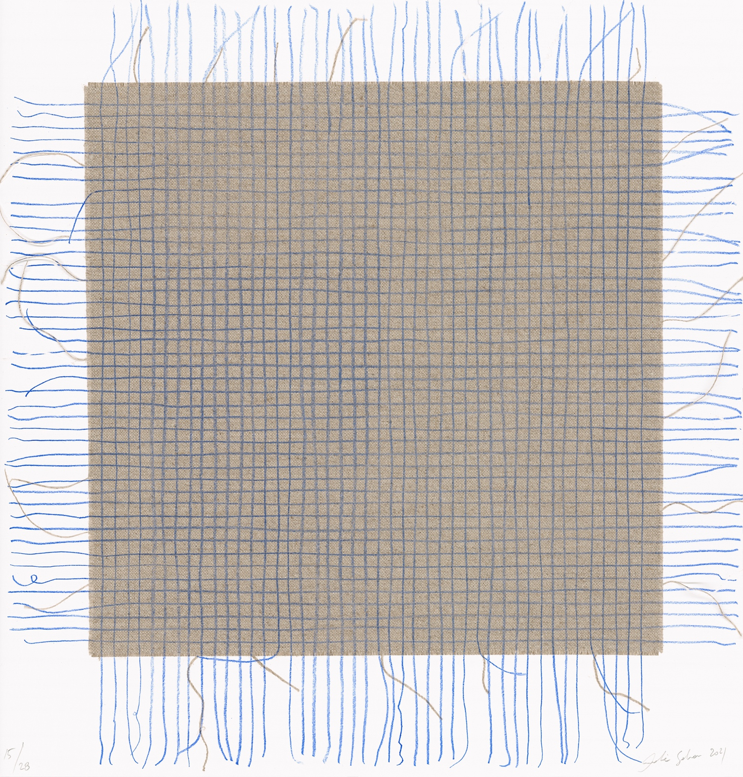

Analía Sabán, Transcending Grid, Blue, 2021
1-color soft ground etching with linen chine collé
17 ½ x 16 5/8 inches
Edition of 28

