FOR IMMEDIATE RELEASE – October 22, 2022
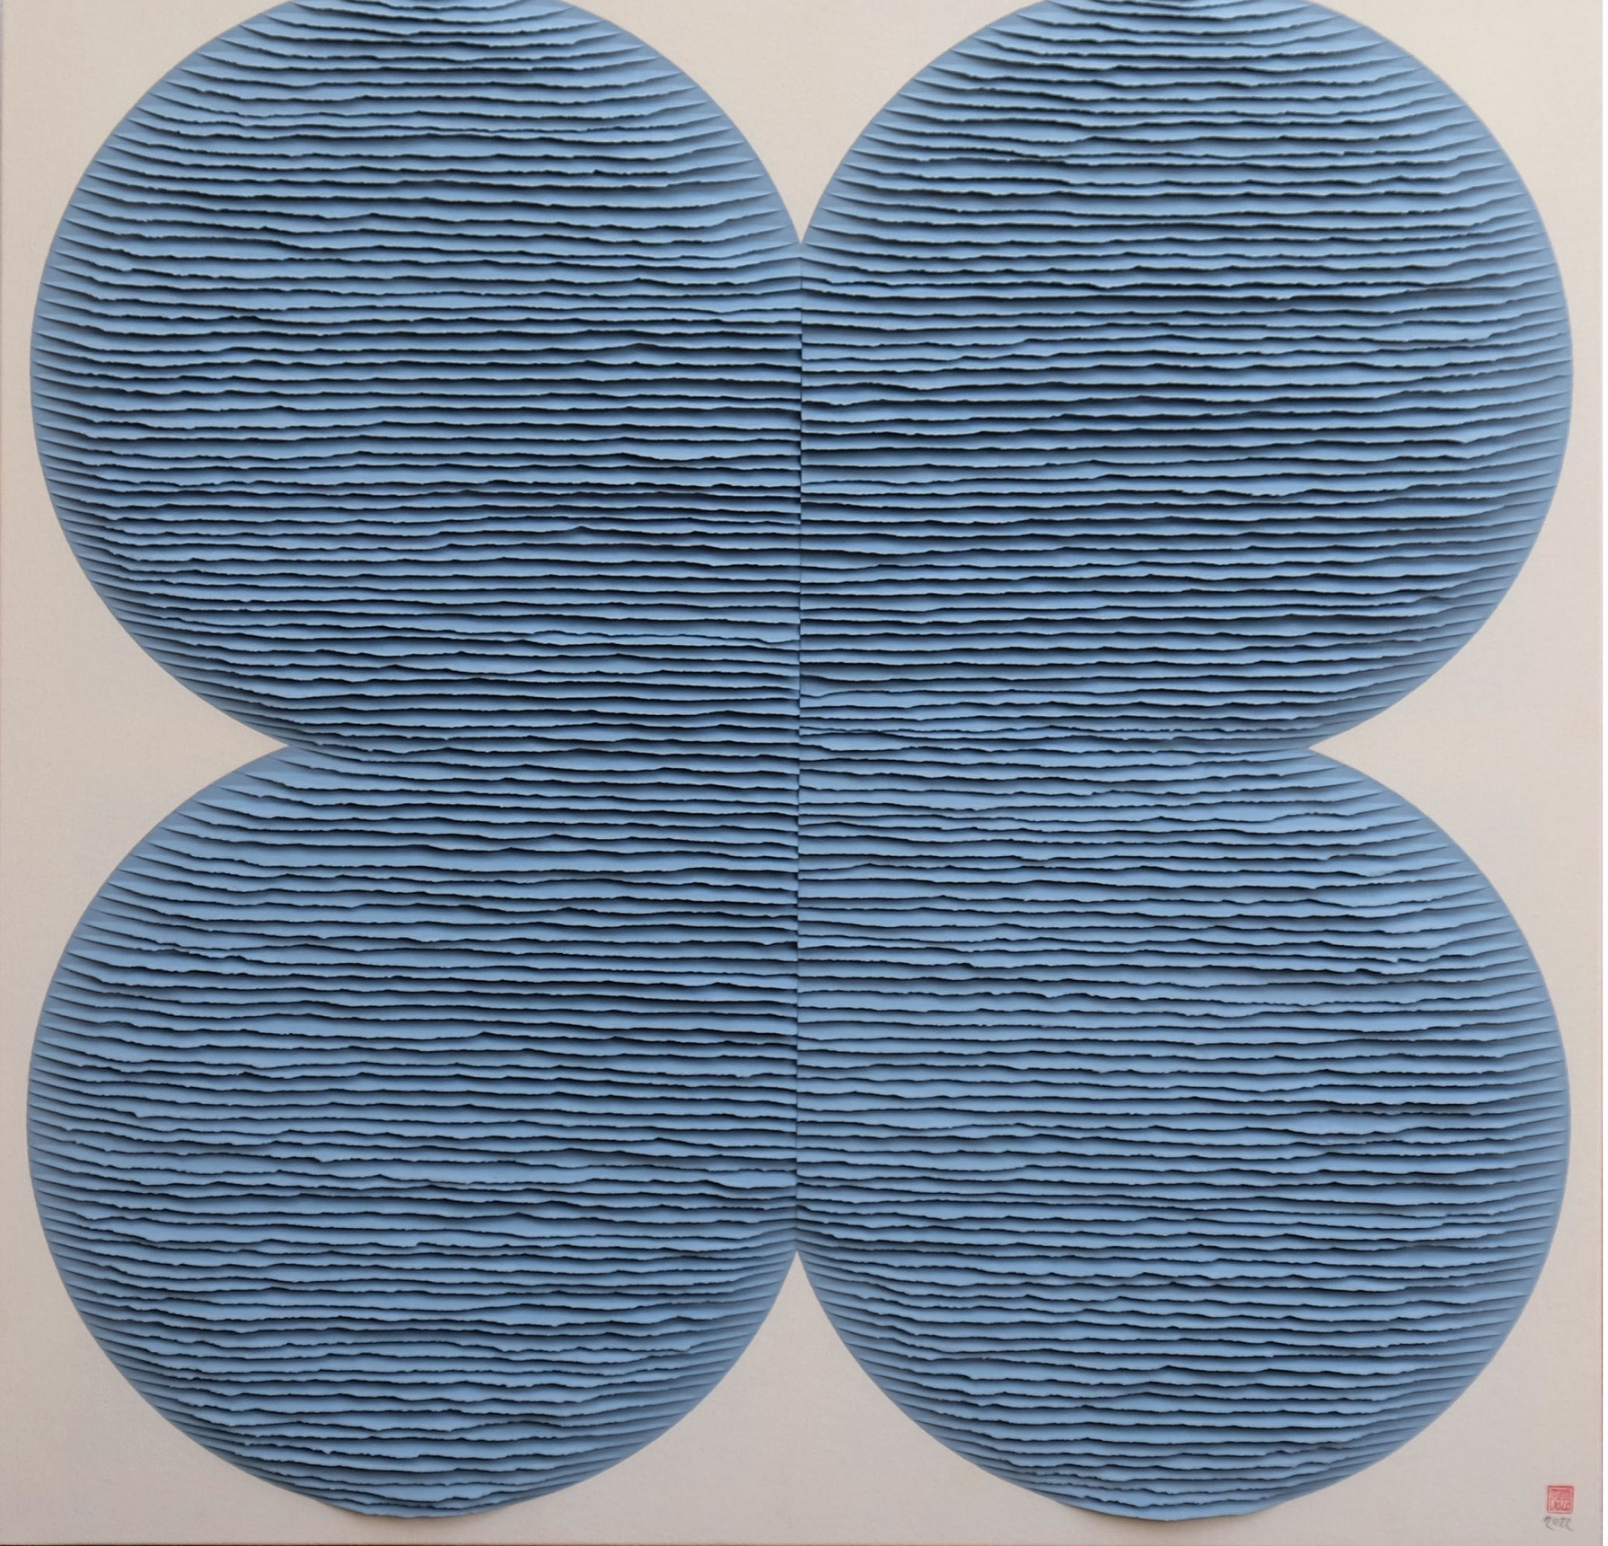
Heather Gaudio Fine Art
66 Elm Street
New Canaan, CT 06840
(203)801-9590
www.heathergaudiofineart.com
email: rachael@heathergaudiofineart.com

Heather Gaudio Fine Art is pleased to present Fernando Daza: Estructuras en Papel, the Spanish artist’s first solo exhibition in the United States. The show will feature newly created works on paper and will run December 10th, 2022-January 21st, 2023.

Daza’s works are adroit investigations of form, color, light, shadow, and texture. His medium of choice is monochromatic Casson paper, which he meditatively tears by hand before precisely mounting onto canvas. Arranged in overlapping layers, the sheets form simplified geometric shapes that create dialogues with juxtaposed structures. Squares within squares, rectangles positioned perpendicularly to one another, or lines cutting across circles are among his modernistic configurations. Daza enhances his visual vocabulary by rendering the shapes with chromatic interactions through the use of opposing or complementary colors. The image complexity can be further emphasized when the works are presented in diptych or multipaneled formats. Although much of the artist’s vernacular relies on hard-edge, Minimalist abstraction, his works are softened by the texture of the torn sheets of paper. Daza presents another formal variable by mounting the paper onto a bare canvas which accentuates the clean lines of the colorful forms. Typically, the canvas is associated with painting, yet here there is no gesture made with the brush or paint. This unexpected choice of backing material adds to the deceivingly simple formal proposals Daza delivers, appealing in their reductive shapes with their compelling relationships.

The artist received a Bachelor of Fine Arts from the University of Seville in 2003 and subsequently participated in a printmaking program at the University of Athens. He has been the subject of many solo and group shows in Europe, and his works are included in numerous public and private collections here and abroad, such as the National Gallery of Kosovo, Pristina; National Museum of Contemporary Art, Macedonia; and the Muzej Vojvodine, Novi Sad in Serbia.

Above: Blue Flower, 2022, hand-torn paper mounted on canvas, 47 x 47 inches

Heather Gaudio Fine Art specializes in emerging and established artists, offering painting, works on paper, photography and sculpture. The gallery provides a full range of art advisory services, from forming and maintaining a collection, to securing secondary market material, to assisting with framing and installation. The focus is on each individual client, selecting art that best serves his or her vision, space, and resources. The six exhibitions offered every year are designed to present important talent and provide artwork appealing to a broad range of interests. Gallery hours are Tuesday through Saturday; 10:30am to 5:30pm; and by appointment.
For more information and/or high-res images, please contact Sophia Ziotas, sophia@heathergaudiofineart.com

Fernando Daza, Blue Japanese Screen, hand-torn paper mounted on canvas, 60 x 98 inches

